Module 3 Reflection – Task 3.3 Lorraine Taylor – 11052568
Feedback August 2011
Course 261.760 – Instructional Design

Feedback

Introduction

Feedback is an integral part in designing learning and instruction. It can be formative or informative, self or peer oriented, positive or negative, constructive or destructive, and it can be group or individually focused. Feedback can be shared face-to-face or in an online forum. The term feedback can often be seen as static or limiting because it focuses on past events. A couple of years ago I came across the term feed-forward which is more expansive and dynamic as it focuses on the future and it’s purpose becomes one of helping people to achieve their goals. Glaser (1984, as cited in Ekenberg, 2001) argues that teaching is most effective when it takes place in the context of future tasks or problems. Ideally, feedback should not only reflect on past events, but should also, challenge and inspire the learner to move forward in the pursuit of their goals.

The Role of Feedback

Feedback was often given as a point total or percentage mark on a cumulative assessment. Successful students then were those that learned how to pass assessments, not necessarily those who had the deepest understanding of the subject matter. Learning systems now incorporate feedback in multi-faceted forms incorporating both face-to-face and online learning (Mayes, 2004). Sims (2006) has found that we can maximize the personalization of feedback by incorporating self-evaluation and self-assessment. As a returning student to University, I have found that I am actively involved in regularly providing feedback through online forums, portfolio submissions, and peer and self- assessments. I have become immersed in a learner-centered collaborative context where feedback is an integral part of the learning design (Sims, 2006). Brown and Duduid (1993, as cited in Ekenberg, 2001) argue that people are able to learn fairly complex skills provided the social context gives incentive to and is supportive of learning. This has certainly been my experience as I have become engulfed in the learning and dialogue of the courses I have taken at University this year.

Implications for Learning Design

I have often been fascinated with the success of the science behind the design of virtual games. I recently participated in an online forum with Julie Dirksen, a Senior Instructional Strategist with Allen Interactions. She explains that when we learn something new, the frontal cortex in our brain gets busy processing information and it is like biking uphill. When learning design is structured in a way that new information is continually added, the learner experiences a long uphill bike ride. In such cases, the learner often switches off and in some cases gives up and does not complete the task.

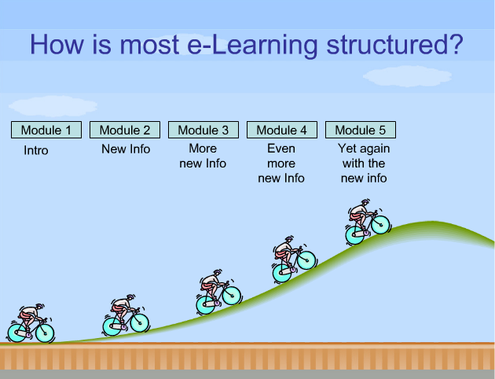

(Dirksen, 2006)

Julie Dirksen explains that the way games are designed is that there are regular intervals dedicated to reflect on what has been learned. At this time the brain leverages the basal ganglia and runs without conscious attention. It reflects on what has been learned. She likens this to biking downhill or coasting. Feedback needs to be integrated into learning design so that the brain has time to coast and reflect on what it has learned. The ‘boss fight’ at the end of the uphill climb is the event that Dirksen refers to when all the skills that have been learned are used to conquer the final task. The learning portfolios that I am completing for each of my courses are in a sense my boss fight. It is when I combine all that I have learned through the participation within a community of practice to complete a final reflection that was created as an ongoing and cumulative work. This has replaced the once final exam that courses use to have. It ensures that learning is cumulative, continuous, and is integrated with peer and self-feedback.

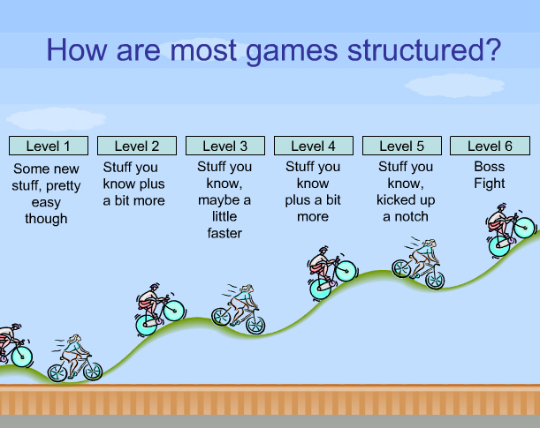

(Dirksen, 2006)

Integrating Feedback into a Learning Environment

Toastmasters Speaking Clubs integrate self and peer reflection into the design of their speaking and training programs. They use a method of CRC, commend, recommend, and commend. This is highly effective as it encompasses the idea of feed-forward by reflecting on a delivery of a speech in order to provide reflection useful for all speakers of the club. Evaluation is an integral part of all levels of the club that highlights the importance of feedback and blurs the lines between those that mentor and those that learn. These roles are interchangeable within the club. The elements of Toastmasters can easily be incorporated into developing effective learning environments.

Twenty years ago when I was completing my bachelor’s degree I assisted a Professor with the courses that she was teaching. Today as I participate in online learning it is apparent that feedback is an integral part of online learning. Instructors and course facilitators should not and cannot provide feedback at all times. However, in an undergraduate course, for instance, it is necessary that enough feedback be given in the initial stages to ignite the flow of communication among members to assist the lurkers to become more actively involved in the learning community. Online assistants that are becoming experts in their field can provide useful feedback and spark communication. This provides an added advantage to graduate students who have a developing expertise in a subject but can also benefit from engaging in subject matter conversations that they are currently researching. Enkenberg (2001) believes that undergraduates from the very beginning of their studies should be in contact with professional researchers and the problems facing them. Research should be encouraged from the initial stages of learning a craft.

Feedback is, undoubtedly, an integral part to the learning process. The work and research that Sims (2006) has completed in the last twenty-five years suggests that computers in a learning and performance context should be used for course participants to deconstruct, construct and reconstruct their mental models so that information transmission strategies can be most effective. At the core this involves integrating feedback successfully into a community of learners.

References

Dirksen, J. (Producer). (2006, 2011) BAM! EEEEEK! POW! What video games can teach us about elearning feedback. eLearning Guild Online Forum p70628891.
Ekenberg, J. (2001). Instructional design and emerging teaching models in higher education. Computers in Human Behavior, 17, 495-506.
Mayes, J. T., & de Freitas, S. (2004). Review of e-learning theories, frameworks and models. JISC e-learning Models Desk Study, (1). Retrieved from http://www.jisc.ac.uk/uploaded_documents/Stage 2 Learning Models (Version 1).pdf
Sims, R. (2006). Beyond instructional design: Making learning design a reality. Journal of Learning Design, 1(2), 1-7.

