Getting started with MyPortfolio

MyPortfolio helps you document learning over time so you can then reflect on what you have done and set goals for further development.

This guide will introduce MyPortfolio and give you a brief overview to get you started. Further help is available at http://myportfolio.ac.nz/.

MyPortfolio is run outside the Massey University computing system so you can access it after you leave Massey.

Contents

Support 1
About MyPortfolio 2
Definitions 3
Register for MyPortfolio 3
Explore MyPortfolio 4
Add details, goals and skills 4
Create a Blog 5
Create a View 6
Edit your View 8
Groups and team working 9
Add files to MyPortfolio 9

Support

There are guides available at http://myportfolio.ac.nz/. These guides are on:
- Login, profile and settings
- Résumé builder
- Blogging
- Uploading resources
- Creating Views
- Groups, Forums and Friends
- Quick Admin Guide
Any problems with MyPortfolio contact the ITS helpdesk or
John Milne 04 801 5799 ext 6128 or j.d.milne@massey.ac.nz

About MyPortfolio

There are three key areas to MyPortfolio:

- Material about your learning can be stored in MyPortfolio. You can record evidence using blogs or store assignments, photos, or other files. Provide information in the profile including your goals, resume and skills.

- Views allow you to build Web pages that showcase your learning material for your lecturer, classmates, employers or others. A View can also be private for your personal learning.

- Groups help you work with others. You can link a variety of Views to a group.

These three areas link together. The material such as blogs and files can be added to Views. These Views can be private or shared. The View can be shared with a Group which links people together.

Three key areas in MyPortfolio
Blog
Material Views Groups

Word documents
Personal View eg blog and contact detail
Project team
Profile contact details
Group View
eg project specification
Personal view about course

Definitions

ePortfolio A valuable learning tool based on a website where you can store information, examples and evidence related to your skills and achievements. EPortfolios can be a powerful tool when used to demonstrate competence and help learners reflect. EPortfolios also allow students to share and communicate.

MyPortfolio The ePortfolio system that is available to Massey staff and students. It is run outside the Massey University computing system so you can access it after you leave Massey.

View A Web page that allows you to present material in MyPortfolio. A View can be private or you can share it with others. Only the person who creates the View can edit it although if you give others access to it they can provide comments at the end of the View.

Blog A Web page that allows you to record your ideas and information. To allow others to read and comment on your Blog you need to add it to a View.

Group Some people who use MyPortfolio and work together on a project or task. They can collaborate and create Group Views, use discussion forums, share files, or share personal Views.

Group Views A View that is part of a Group that all the members of the Group can edit. Note that this is different to a personal View in that in a personal View only the person who created it can edit it.

Register for MyPortfolio

The first thing you will have to do is register. Decide on a username and password. If this is the same as you use at Massey it will be easy to remember.

Register at http://myportfolio.ac.nz/register.php

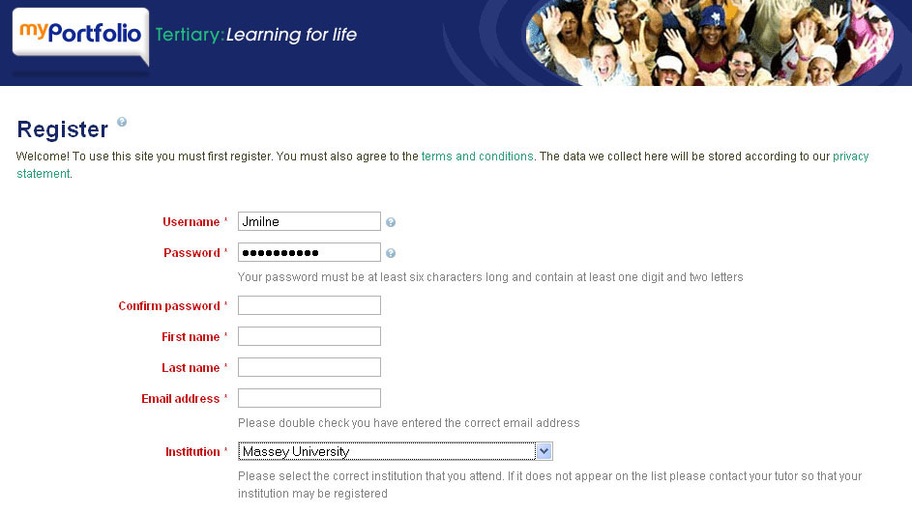
Fill in your details and you will get an email with a link to MyPortfolio

To complete registration an email will be sent a few minutes after registering. Open this email to complete registration. If you have a problem contact:
John Milne 04 801 5799 ext 6128 or j.d.milne@massey.ac.nz

Explore MyPortfolio

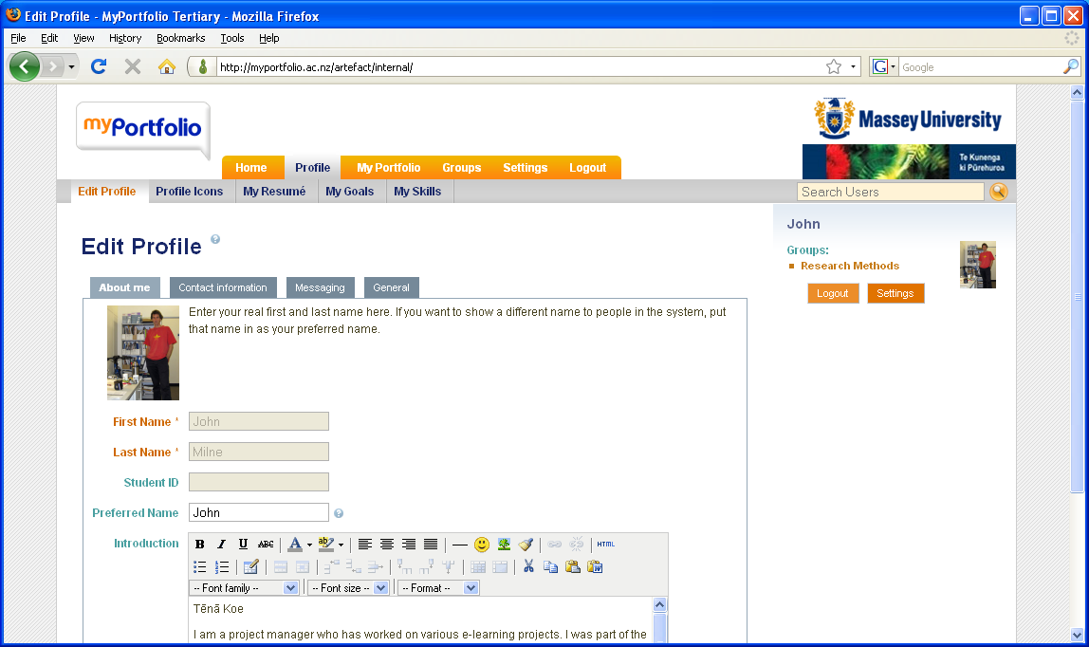
Explore the site using the menus.

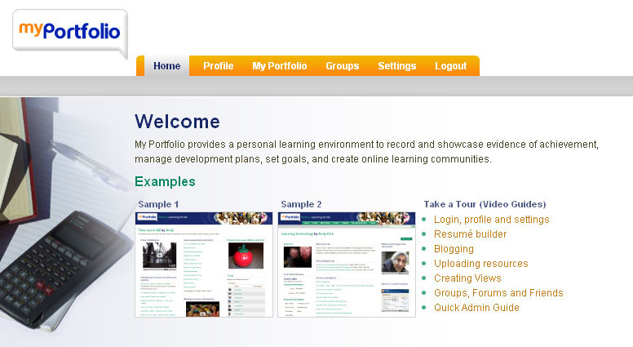
‘How to’ guides are available at the Home page

Add details, goals and skills

The Profile area is where you put your contact information and details about your goals and skills. Go to the menu Profile then Edit Profile and add your details.

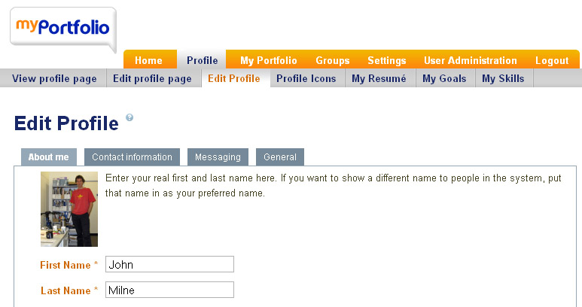
When you have completed the profile details add in goals, skills and resume details

Create a Blog

Create a Blog within MyPortfolio in two steps. Create a title and description for the blog. Then, you can add Blog posts. This is outlined below. Blogs are private. To share them you need to add them to a View (see page 5).

1) Go to the menu MyPorfolio then MyBlogs and set up the blog.

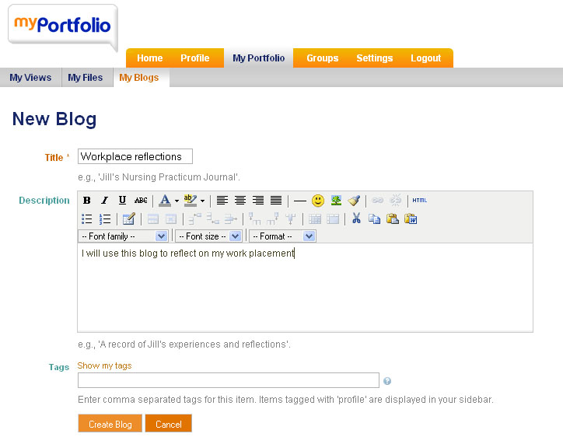
Add a title and description and then press the ‘Create Blog’ button

2) Add a post to the blog

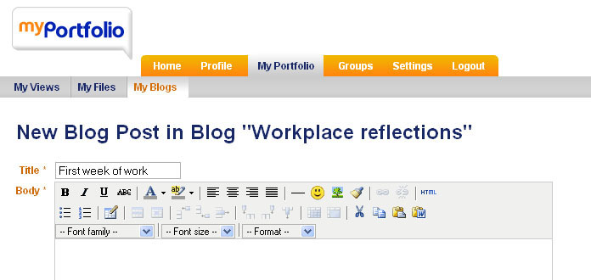
Add a title and content to your blog. Make sure you press the ‘Save post’ button at the end of the page.

Create a View

A View allows you to present material in MyPortfolio. A view can be private or you can share it with others. Only the person who creates the View can edit it although if you give others access to it they can provide comments at the end of the View.

Share your blog with others by creating a View.

1) Go to the menu MyPorfolio then MyViews then Create View.

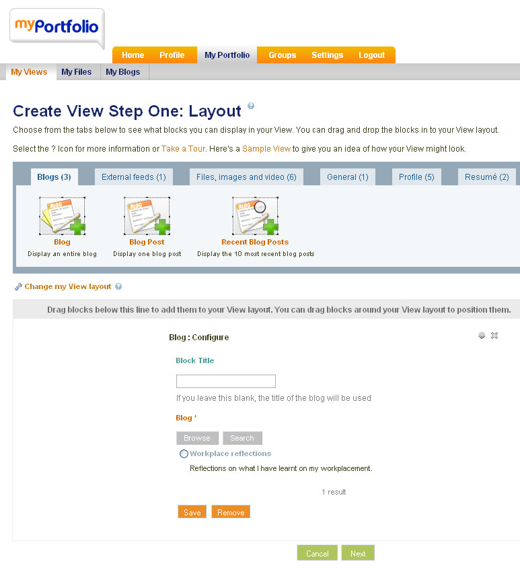
Move the ‘Recent Blog Posts tool to the View section. Give it a title and select the Blog you want to add.

2) Change the look of your View

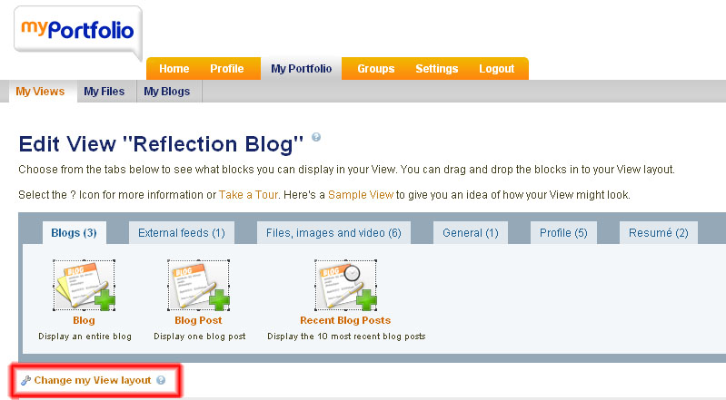
Change view layout allows you to change the number of columns in the View. Try 2 columns of equal size.

3) Add profile information and goals to your View

Go to Profile and add Profile information

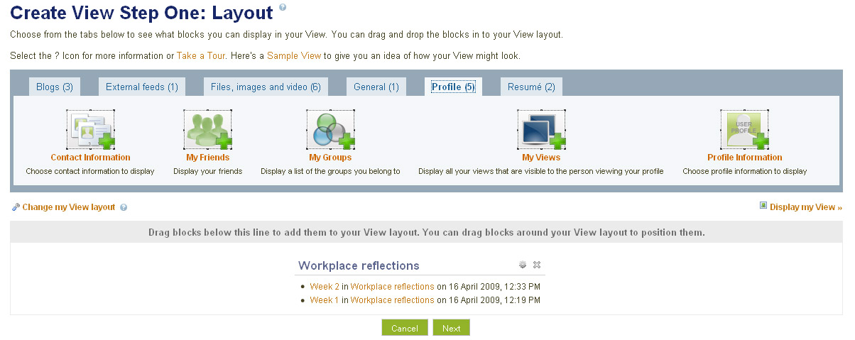

4) Add details about your View

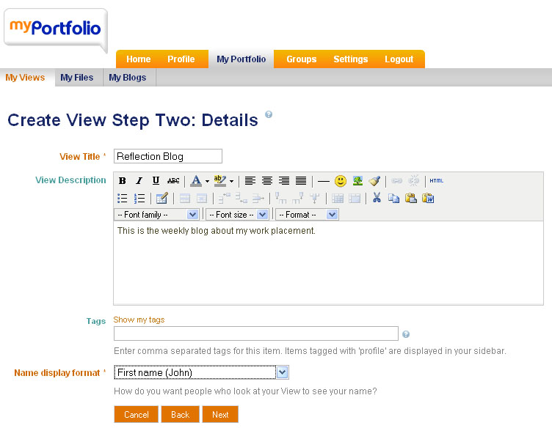
Give your view a name and description.

5) Give people access to your View

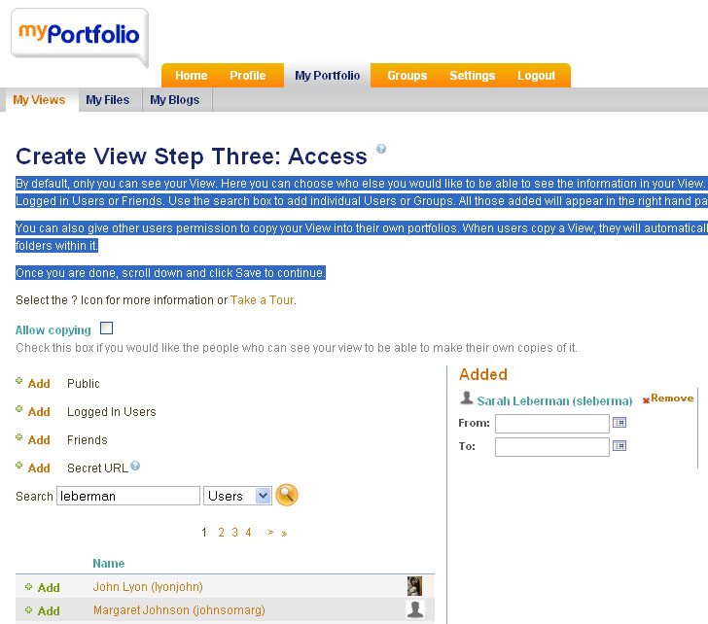
Search for the people you want to give access to the View. Select the save button at the end of the screen.

Edit your View

Go to the menu MyPorfolio then MyViews and you will see a list of your Views. You can edit the details, the view or the access.

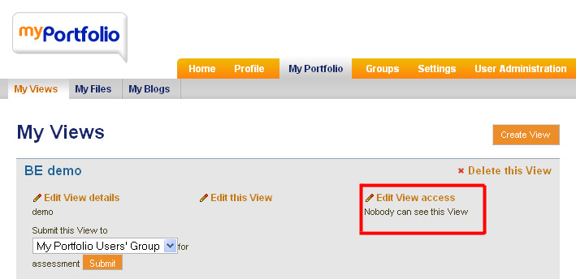
Go to ‘Edit View Access’ to allow the class access to your view.

If you choose ‘Edit this View’ select the cog to edit the blog.

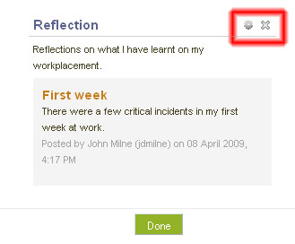
Select the ‘cog’ to edit the blog.
The ‘x’ will delete the blog from the View.

Groups and team working
Use MyPortfolio groups to share material and discuss what your team needs to do.

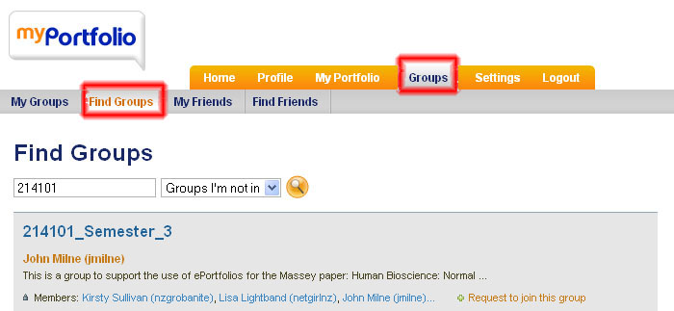
Go to Groups, select ‘Find Groups’
Search for a group and request to join

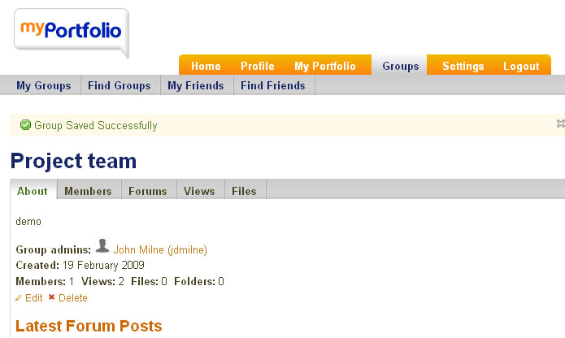
In the group you have a - Forum for discussions,
- Views that the group
can create
- Files where you store
files

Add files to MyPortfolio

Upload files such as assignments. To share them you need to add them the file to a View.

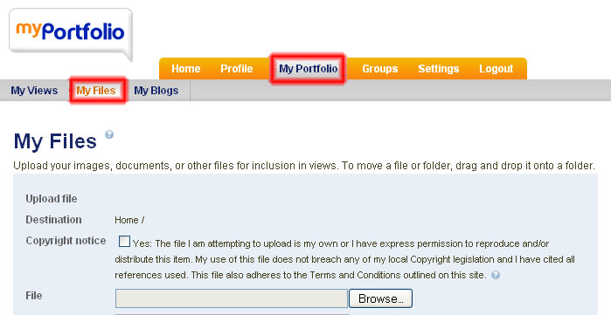
Select My Portfolio
then My Files and
upload your files

